CSC 403 ICE 4 Name

1. Convert the 2-3 tree below to an equivalent red-black tree.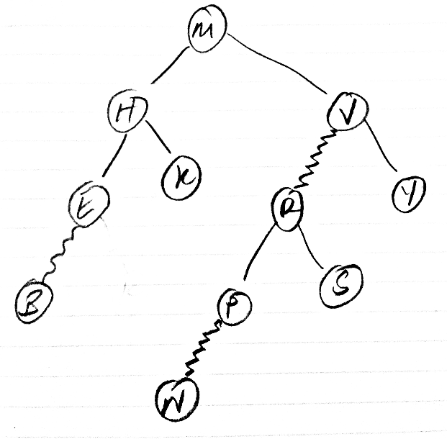

M

M

H

K

B E

S

R V

N P

Y

1. Show the result of inserting the key “C” into the 2-3 tree from #1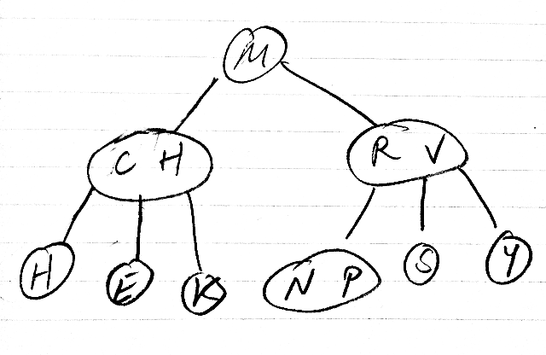
2. Show the result of inserting the key “Q” into the 2-3 tree from #1.

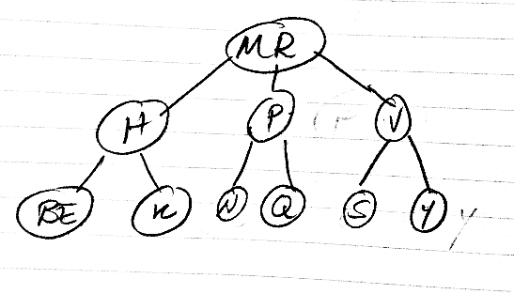

1. Paraphrase any two non-consecutive questions asked during class (by anyone) along with the answer.

At 1:29:45, a student asked if 2-3 BSTs have logarithmic performance in search and insert, to which the answer was yes.

At 2:33:54, a student asked about the size property in the rotateLeft() and rotateRight() methods in the book. The answer was that you’d take a look at it.